3.Draw and explain the life cycle of a butterfly.

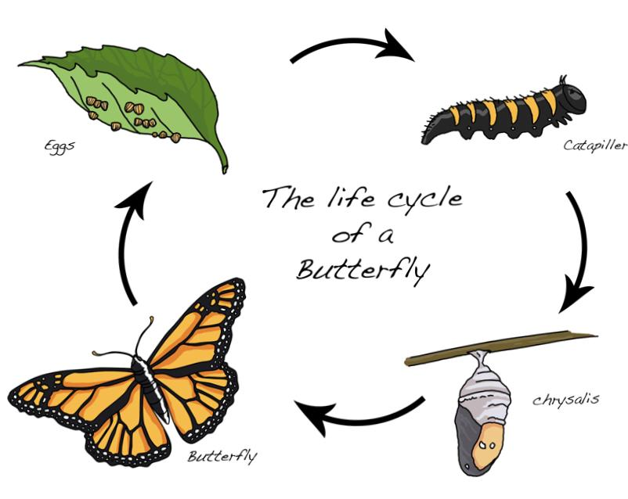
Egg:
A butterfly lays tiny eggs on leaves.
Larva (Caterpillar):
The egg hatches into a caterpillar. It eats leaves and grows fast.
Pupa (Chrysalis):
The caterpillar forms a hard covering called a chrysalis. Inside it changes its body.
Adult Butterfly:
A beautiful butterfly comes out. It can fly and lay eggs again

